Xinyue Zhang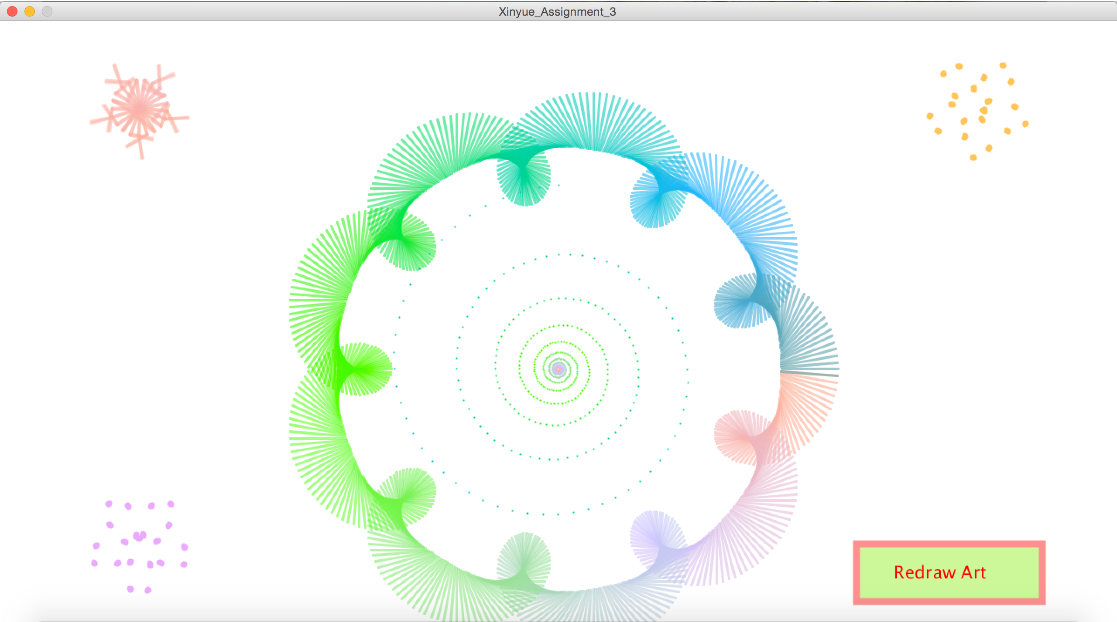

CS 110 - Section 1

Professor Tao

Feb 24th, 2015

Assignment III

TITLE: Creative String Art: “Sunflower”

Short Description:

This assignment is a creative art designed using string art. String art is a kind of abstract computational art based on trigonometry. I got my inspiration from the online link provided on the assignment page. This project is contained of a colorful garland in the middle with spirals inside it. Besides, there is a snow flake at the upper left corner, and two flowers at the upper right and lower left corners. The creative parts of my coding are the if loops controlling these shapes. Basically, the shapes will be drawn dynamically and at a given point, stopped as a static art. Another feature of this project is a button named "Redraw Art", which will redraw the graph when clicked.

More Detailed Description:

For the third assignment, I designed a dynamic string art which changes the stroke color while drawing.

For my coding procedures, I further practiced the use of variables and functions; specifically remembered to add the function comment at the beginning of each function. In this assignment, what I learned most is the importance of design including the aesthetic as well as the mathematics part before real coding. The comparably challenging part goes to the trigonometry logic behind the project (specifically the selection of sin and cos functions for clockwise and counterclockwise movement). I started this project pretty early, so it did take me a while figuring out the logic behind those string arts shown in the link. It was a really fun experience coding out those beautiful string arts and creating my own design. Besides, I figured out a colorful way to draw shapes based on the original strokeColor and strokeDeltacolor variables I learnt in class. However, the console becomes really busy and messy while the draw() function continues to loop and draw shapes on top of the original. To solve that issue, I first created a button(using rect() and text() functions) which redraw the shapes from the beginning. Finally, I figured out a better way by adding several if conditions to control the functions.

Overall, I strengthened my coding skills with different functions and small interactions, and also familiarized with the string art based on several trigonometry. I dedicated a lot of effort to this assignment but it was a lot of fun.